**FI CONSULTING CASE INTERVIEW**

**Instructions:**

As part of your in-person interview with FI Consulting you are being asked to complete a case study. You will be given (4) days to complete it. If you have questions while you are doing your research and analysis please reach out to me at [cluchetti@ficonsulting.com](mailto:cluchetti@ficonsulting.com) and I will get them answered for you.

Your completed case is due back (24) hours prior to the date of your interview. You should be prepared to present your work to the interviewer when you come in. They will be acting as the client, sitting with you as you describe your analytical work. The interviewer will ask questions throughout the presentation and may also provide feedback. Please be prepared to incorporate small adjustments to your analysis during the interview.

**Case Interview: Inflation and Unemployment**

William Phillips, a New Zealand born economist, wrote a paper in 1958 titled The Relation between Unemployment and the Rate of Change of Money Wage Rates in the United Kingdom, 1861-1957, which was published in the quarterly journal Economica. In the paper Phillips describes how he observed an inverse relationship between inflation and unemployment in the British economy over the period examined. This relationship became known as the Phillip’s Curve.

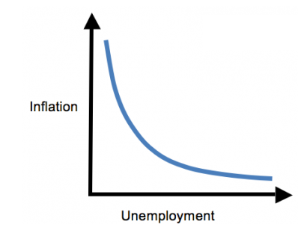

Our current client, the US Department of Economics would like us to perform an analysis on the relationship between unemployment and inflation. Your manager has asked you to complete two tasks:

1. Using the Federal Reserve data that was provided, please analyze and critique William Phillips’s theory to determine if the relationship holds in the United States.
2. Explore the relationship between inflation and the unemployment rate from a unique perspective not previously explored by William Phillips. Use of additional data sources to support your analysis is highly encouraged.

Please be prepared to present your results and observations from the analyses to the client. When conducting your analysis, please keep the following requirements and guidelines in mind:

1. Analysis must be reproducible. Manual steps in the analysis should be limited (i.e. dynamic formulas should be used wherever possible as opposed to hard-coded, static values).
2. Analysis should be quantitative in nature. The analysis can be completed in any of the following tools. **Please let us know right after you have reviewed the case material which software you choose to conduct the analysis in.** 
   1. Microsoft Excel (VBA is optional)
   2. R
   3. Python
   4. SAS
   5. Microsoft Power BI
   6. Tableau
   7. SQL
3. Analysis must calculate inflation rate and unemployment rate using the provided data. The use of additional datasets for the exploratory analysis is highly encouraged.
4. Data visualization should be used in analysis and/or reporting final results.
5. Be prepared to make edits to your work during the interview based on feedback.
6. If you have a laptop, please bring it in to present your case study on for the interview day. If you don’t have a laptop, please let us know, and we are happy to have you use one of our laptop’s to present.